Part 1: Descriptive Statistics.
Name: Aimee Steinwand
Group: Maddie, Kayla, Yemi
- Based on the graphs of PSA and the other variables in the analysis are there any concerning patterns that might result in violations of linear regression assumptions? If yes, discuss a solution to your concern.
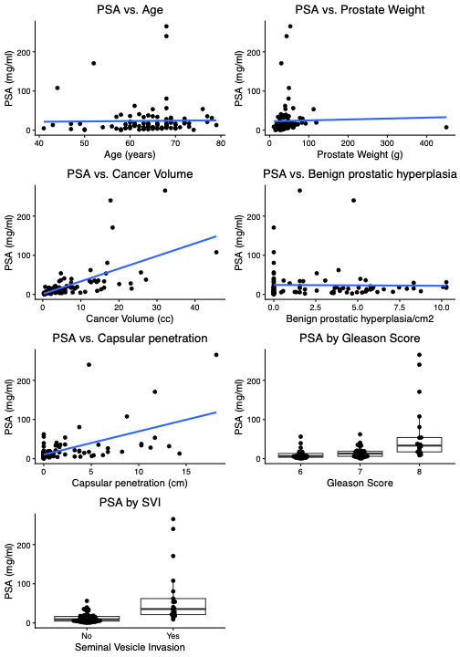
- Yes there are linearity and normality concerns due to potential outliers/skewness
- Potential solutions, remove outliers or log transform variables, ask investigator about any mistakes (400g vs 40g)
- Below are a set of pictures with PSA log transformed for analysis and the very large weight value removed. Are there any remaining concerns with using linear regression on these data? Justify.
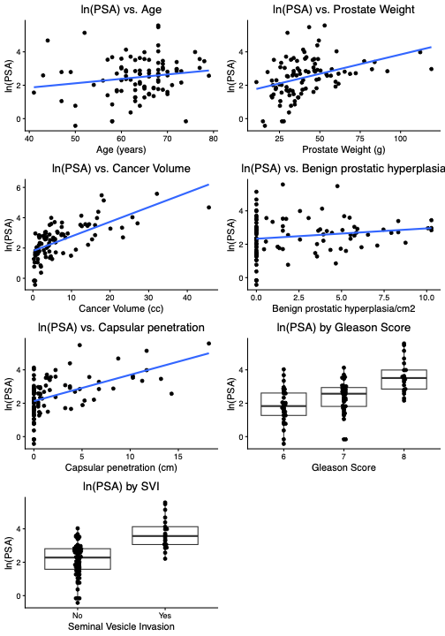
- Inflated zeros for the capsular penetration and benign prostatic hyperplasia
- Zeros could cause issues with equal variance assumption

- Modify your draft data analysis plan for your Bayesian regression analysis. At this point, this should include the above information, the Bayesian regression framework and some information about the distributions of the priors. You may also include non-informative or vague priors in your writing at this point. Questions to think about: 1) what models will you fit with what variables, 2) what model building strategies will you use?
Analysis Plan
- Models
  - Log(PSA)
    - Univariate associations for each covariate – get individual associations
    - Multivariable model – to understand what is associated with PSA
    - 8 predictors, 97 observations
    - Assess their interaction terms
    - SVI x individual variable, interaction models
  - Priors
    - Half-normal non-informative with big variances
    - Normal (0, 1000) for covariates
  - Backwards selection starting with all of them and removing them

Part 2: Consider investigating the association between log(PSA) and Gleason Score.

- Write down your statistical model and corresponding likelihood for estimating this association.

Log(PSA) = beta_0 + beta_1(Gleason=7) + beta_2(Gleason=8) + error

Log(PSA)|beta_0, beta_1, beta_2, sigma^2~ Normal(mu, sigma^2)

- Write down the priors for the parameters in this model.

beta_0, beta_1, beta_2 ~ Normal(0, 1000)

error ~ half-normal(0,5)

- Write down parameters in your priors for the regression coefficient on Gleason Score that make for non-informative, skeptical, and optimistic priors. Expert opinion priors are a bit tricky to do in class, since we don’t have an expert.
Non-Informative: Normal(0, 1000)
Skeptical: Normal(0, 100)
Optimistic: Normal(10, 1000)
- The output for this model is provided below for the non-Bayesian linear model estimates and Bayesian posteriors. Interpret the association between Gleason Score and Log(PSA) in a sentence or two using a Bayesian framework.
gleasonmodel <-lm(lpsa ~ gleason, data=psaclean2)
summary.lm(gleasonmodel)

Call:
lm(formula = lpsa ~ gleason, data = psaclean2)

Residuals:
Min 1Q Median 3Q Max
-2.54621 -0.59562 -0.00542 0.59396 2.16434

Coefficients:
Estimate Std. Error t value Pr(>|t|)
(Intercept) 1.8657 0.1715 10.876 < 2e-16 ***
gleason7 0.5204 0.2265 2.297 0.0239 *
gleason8 1.7591 0.2725 6.455 4.85e-09 ***
---
Signif. codes: 0 ‘***’ 0.001 ‘**’ 0.01 ‘*’ 0.05 ‘.’ 0.1 ‘ ’ 1

Residual standard error: 0.9704 on 93 degrees of freedom
Multiple R-squared: 0.3134, Adjusted R-squared: 0.2987
F-statistic: 21.23 on 2 and 93 DF, p-value: 2.548e-08

confint(gleasonmodel)
2.5 % 97.5 %
(Intercept) 1.52502184 2.2063088
gleason7 0.07049249 0.9702521
gleason8 1.21793390 2.3002606

anova(gleasonmodel)
Analysis of Variance Table

Response: lpsa
Df Sum Sq Mean Sq F value Pr(>F)
gleason 2 39.976 19.9878 21.227 2.548e-08 ***
Residuals 93 87.571 0.9416
---
Signif. codes: 0 ‘***’ 0.001 ‘**’ 0.01 ‘*’ 0.05 ‘.’ 0.1 ‘ ’ 1
Table of Bayesian Posterior Results
Parameter | Estimate | Std. Dev. | 95% HPDI
(Intercept) | 1.860 | 0.178 | (1.51, 2.20)
grade7 | 0.522 | 0.233 | (0.0682, 0.993)
grade8 | 1.760 | 0.280 | (1.23, 2.32)
sigma | 0.983 | 0.074 | (0.842, 1.13)
The posterior distributions indicate that both Gleason 7 and Gleason 8 are credibly associated with higher log(PSA)

- Based on this output can you formally assess the “significance” of the association between Gleason Score and Log(PSA) in the frequentist framework? In the Bayesian framework? How would you assess it?

In frequentist framework, we see that both Gleason 7 and Gleason 8 have p-values <0.05 and the CIs do not contain 0, so we can say that the associations are statistically significant.
In the Bayesian framework, neither Gleason 7 nor Gleason 8 have HPDI intervals that include 0, indicating there is a high posterior probability that the Gleason score is positively associated with log(PSA).

